Bull Run Slalom Race, Dec 10,11, 2016
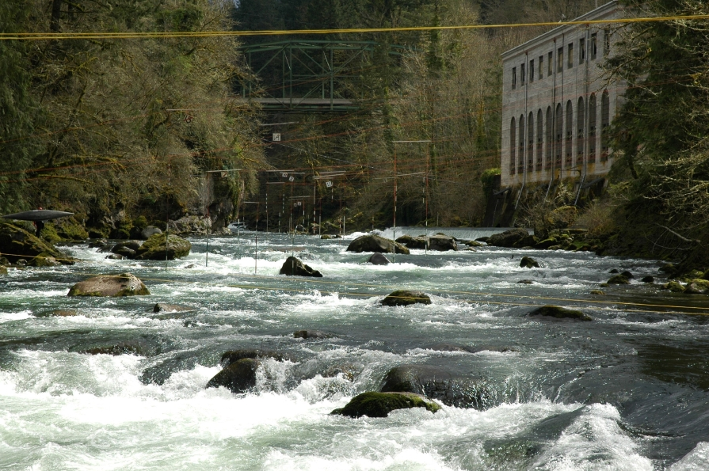
We will be holding the last race of the Northwest Whitewater Slalom Cup at the the Bull River, near Sandy Oregon, Dec. 10, 11.
This race tends to be one of the more difficult of our race series and the river holds some dangers, so you need a very solid roll. However, plastic boaters are most welcome. The river is also prone to going up and down steeply. We will hold the race if the river is > 600 cfs or below 2500 cfs. For the past weeks the river has held at great levels of 100-1500 cfs. The gauge is at: http://www.americanwhitewater.org/content/Gauge2/view/state/OR/ - look for Bull Run at Bull Run and follow where the river is going (rising or dropping) and factor in the weather, whether rain is projected. We will call the race off or on Thursday via an email to this list and the status of the race will be posted at: http://www.nwwhitewater.org/. Email me if you are unsure.
The course will be up and ready for practice on Friday and Sat. Registration will be in the parking lot in front of the fence, on Saturday after 2 pm. Please be sure to register then, it will be $5 extra to register on Sunday. The entry fee for ACA members is $20 per person, $25 for non-ACA members. Google the Bull Run Hydroelectric Powerhouse (SE Bull Run road near SE Waterworks Road) Bull Run River near Sandy Oregon.
Sunday there will be a competitors meeting at 10:00 a.m. in the parking lot. First runs will be at 10:30-11 a.m. All racers will be needed to gate judge in either the morning or afternoon sessions, racing in the other session. Note that this year, we are hoping to have the front and back gates open so that competitors can walk up the course on the asphalt road.

The best way of get there is to exit I#84 going west from Portland at the Corbett then go up the steep hill and onto SE Gordon Creek Rd to SE Bull Run Road and turn right into parking after crossing Bull Run river. You can also get there by going through Sandy Oregon.

Questions: contact David Johnson at: johnsoda7@gmail.com or 503 977 3998 (home).

